Assignment 1 : Combinational Logic Design

- Design and simulate all the six fundamental logic gates OR, NOT, NAND, NOR, XOR, XNOR in Vivado/ Modelsim in dataflow and structural modeling styles.

Dataflow Modelling Code :
/*
Dataflow modelling of the Following gates
1. AND
2. NAND
3. OR
4. NOR
5. NOT
6. XOR
7. XNOR
*/

module and_gate(a, b, y);
input a, b;
output y;
assign y = a & b;
initial $monitor("Time = %0t | AND GATE y = a & b | y = %b", $time, y);
endmodule

module nand_gate(a, b, y);
input a, b;
output y;
assign y = ~(a & b);
initial $monitor("Time = %0t | NAND GATE y = ~(a & b) | y = %b", $time, y);
endmodule

module or_gate(a, b, y);
input a, b;
output y;
assign y = a | b;
initial $monitor("Time = %0t | OR GATE y = (a | b) | y = %b", $time, y);
endmodule

module nor_gate(a, b, y);
input a, b;
output y;
assign y = ~(a | b);
initial $monitor("Time = %0t | NOR GATE y = ~(a | b) | y = %b", $time, y);
endmodule

module not_gate(a, y);
input a;
output y;
assign y = ~a;
initial $monitor("Time = %0t | NOT GATE y = (~a) | y = %b", $time, y);
endmodule

module xor_gate(a, b, y);
input a, b;
output y;
assign y = a ^ b;
initial $monitor("Time = %0t | XOR GATE y = (a ^ b) | y = %b", $time, y);
endmodule

module xnor_gate(a, b, y);
input a, b;
output y;
assign y = ~(a ^ b);
initial $monitor("Time = %0t | XNOR GATE y = ~(a ^ b) | y = %b", $time, y);
endmodule

Structural Modelling Code :

module and_gate(a, b, y);
input a, b;
output y;
and a1(y, a, b);
initial $monitor("Time = %0t | AND GATE y = a & b | y = %b", $time, y);
endmodule

module nand_gate(a, b, y);
input a, b;
output y;
nand n1(y, a, b);
initial $monitor("Time = %0t | NAND GATE y = ~(a & b) | y = %b", $time, y);
endmodule

module or_gate(a, b, y);
input a, b;
output y;
or o1(y, a, b);
initial $monitor("Time = %0t | OR GATE y = (a | b) | y = %b", $time, y);
endmodule

module nor_gate(a, b, y);
input a, b;
output y;
nor n2(y, a, b);
initial $monitor("Time = %0t | NOR GATE y = ~(a | b) | y = %b", $time, y);
endmodule

module not_gate(a, y);
input a;
output y;
not n3(y, a);
initial $monitor("Time = %0t | NOT GATE y = (~a) | y = %b", $time, y);
endmodule

module xor_gate(a, b, y);
input a, b;
output y;
xor x1(y, a, b);
initial $monitor("Time = %0t | XOR GATE y = (a ^ b) | y = %b", $time, y);
endmodule

module xnor_gate(a, b, y);
input a, b;
output y;
xnor x2(y, a, b);
initial $monitor("Time = %0t | XNOR GATE y = ~(a ^ b) | y = %b", $time, y);
endmodule

Testbench :

`ifdef DATAFLOW
`include "logic_gates_dataflow.v"
`else
`include "logic_gates_structure.v"
`endif

module logic_gates_tb;
reg a, b;
wire y_and, y_nand, y_or, y_nor, y_not, y_xor, y_xnor;

and_gate u_and (a, b, y_and);
nand_gate u_nand (a, b, y_nand);
or_gate u_or (a, b, y_or);
nor_gate u_nor (a, b, y_nor);
not_gate u_not (a, y_not);
xor_gate u_xor (a, b, y_xor);
xnor_gate u_xnor (a, b, y_xnor);

initial begin
$dumpfile("logic_gates_tb.vcd");
$dumpvars(0, logic_gates_tb);

a = 0; b = 0;
#10 a = 0; b = 1;
#10 a = 1; b = 0;
#10 a = 1; b = 1;
#10 $finish;
end
endmodule

Compilation :
iverilog -o sim_structure.vvp logic_gates_tb.v # structural (default)
iverilog -DDATAFLOW -o sim_dataflow.vvp logic_gates_tb.v # dataflow
vvp sim_structure.vvp
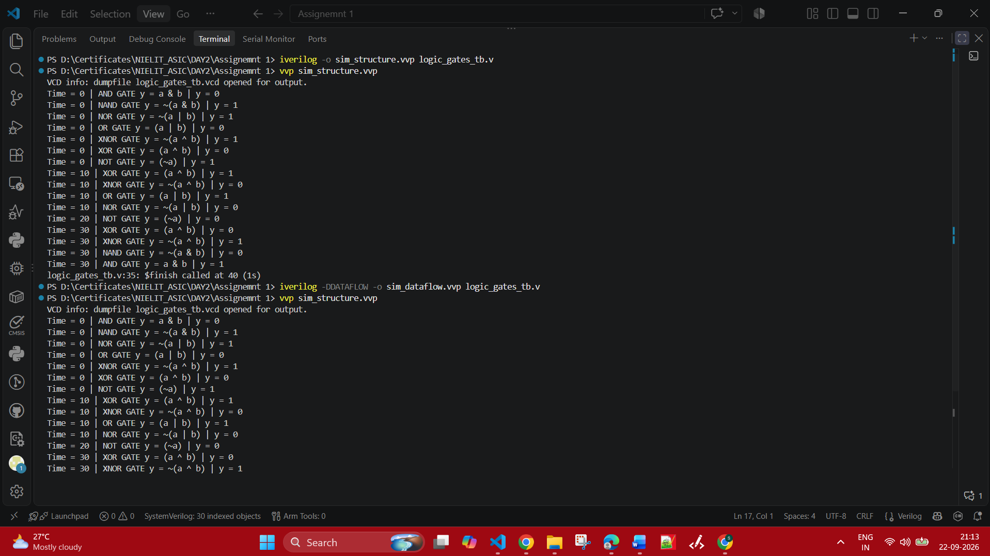
From the Testbench driven :
Every 10ns there is event change in the inputs a and b. The output changes based on the gates and stuff.
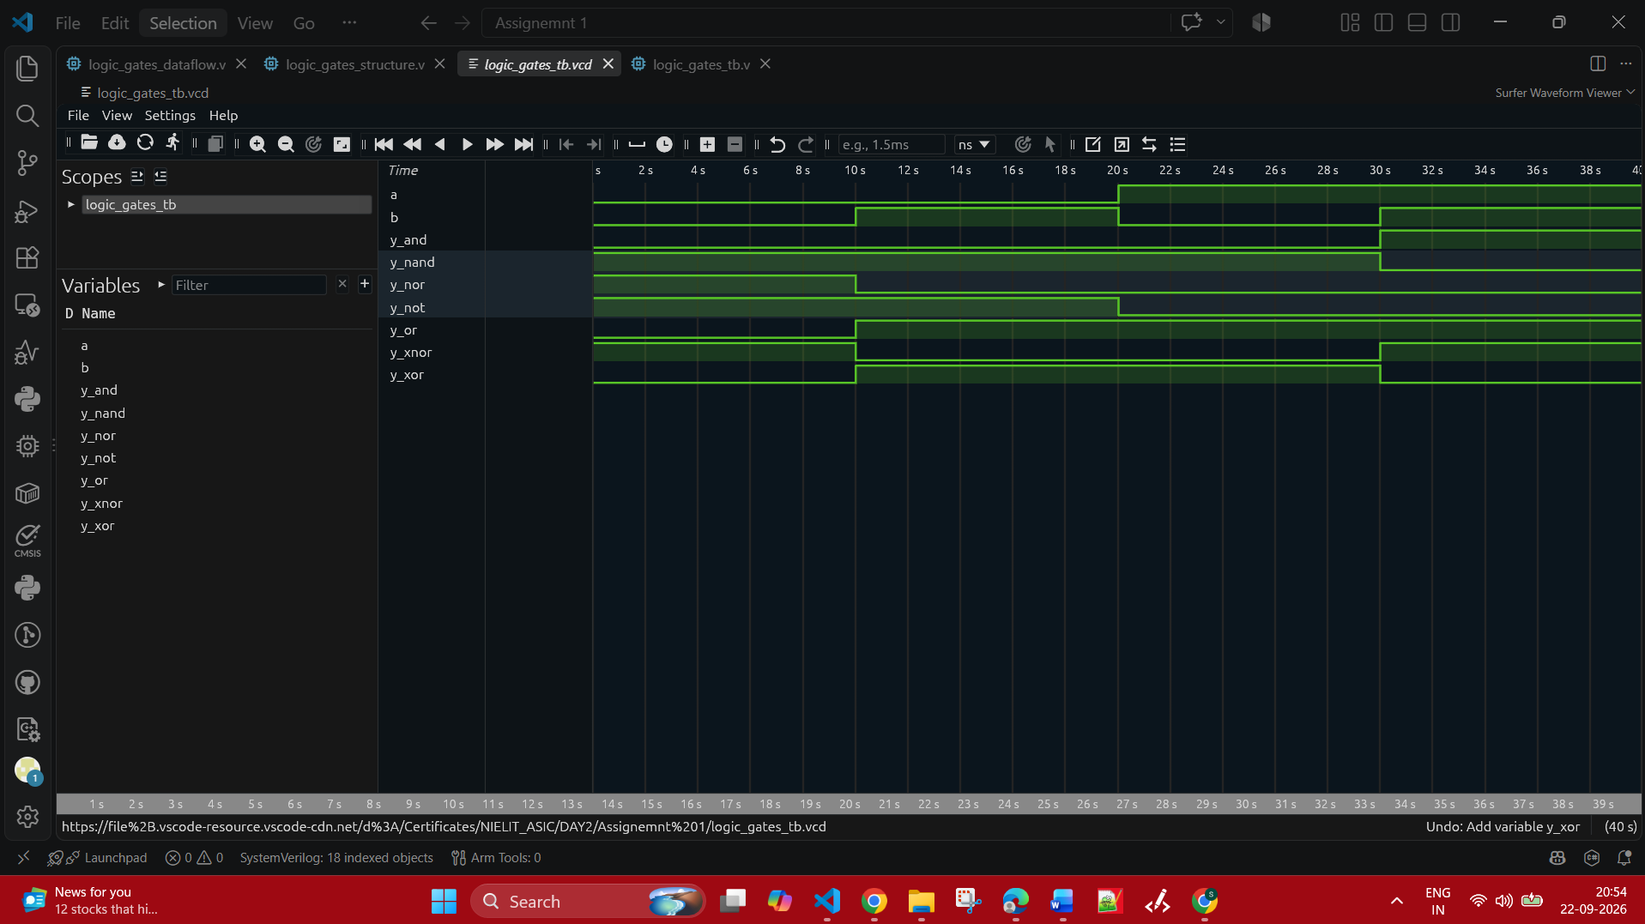
Q2. Design a 2:1 Multiplexer using Verilog HDL in different modeling styles.
- Dataflow Modeling using continuous assignment (assign) statement.
module mux_2_to_1_behavioral (
input wire a,
input wire b,
input wire sel,
output reg y
);

always @(sel, a, b) begin
if (sel)
y = a;
else
y = b;
end

endmodule

- Dataflow Modeling using the conditional (?:) operator.
module mux_2_to_1_behavioral (
input wire a,
input wire b,
input wire sel,
output reg y
);

always @(sel, a, b) begin
if (sel)
y = a;
else
y = b;
end

endmodule

- Behavioural Modeling using always block.
module mux_2_to_1_behavioral_always (
input wire a,
input wire b,
input wire sel,
output reg y
);

always @(a, b, sel) begin
if (sel)
y = a;
else
y = b;
end

endmodule

- Behavioural Modeling using if-else statements.
module mux_2_to_1_behavioral_ifelse (
input wire a,
input wire b,
input wire sel,
output reg y
);

always @(a, b, sel) begin
if (sel)
y = a;
else
y = b;
end

endmodule

- Behavioural Modeling using case statements.

module mux_2_to_1_behavioral_case (
input wire a,
input wire b,
input wire sel,
output reg y
);

always @(*) begin
case (sel)
1'b0 : y = a;
1'b1 : y = b;
endcase
end

endmodule

- Gate-Level Modeling using logic primitives (and, or, not).

module mux_2_to_1_gate_level (
input wire a,
input wire b,
input wire sel,
output wire y
);

wire sel_n, y1, y2;

not(sel_n, sel);
and(y1, sel_n, a);
and(y2, sel, b);
or(y, y1, y2);

endmodule

Compilation of the Mux related Verilog Files :

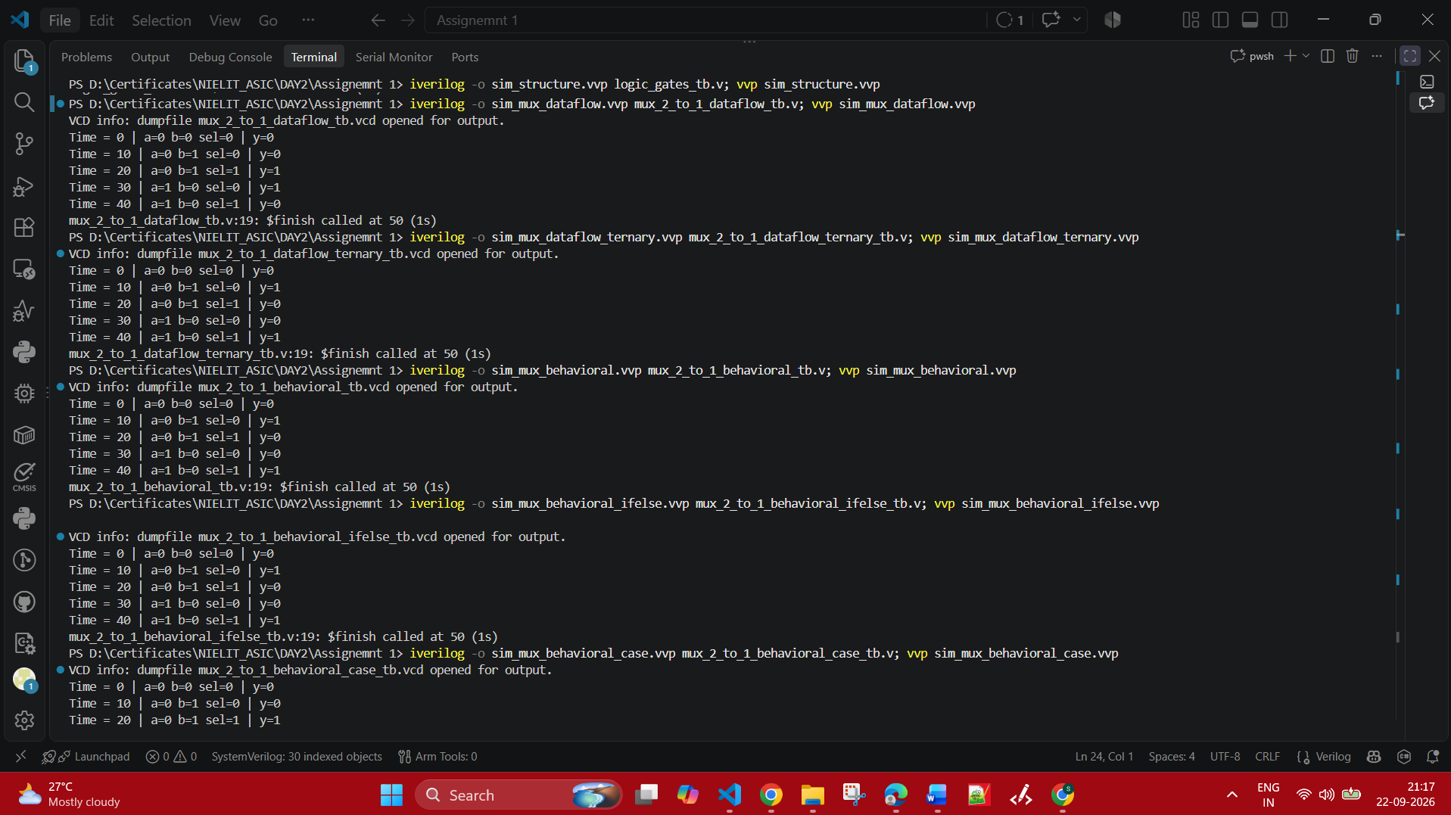

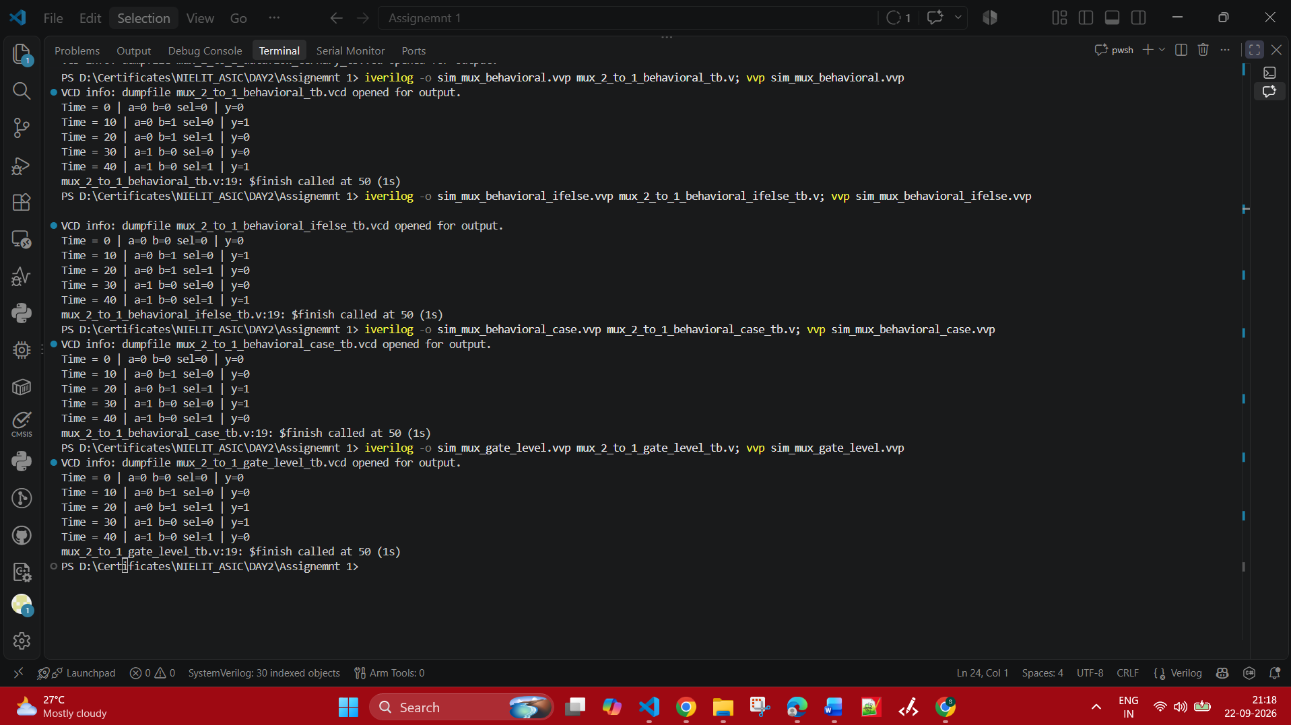

The VCD dumps of the Mux related ones :

